|  |
| --- |
| Maury Regional Medical Center |
| Procedures for Higher Acuity Patients |
|  |
|  |
| | **Admission Assessment** | **Initiated** | **Completed** | **Focused Reassessment Frequency** | | --- | --- | --- | --- | |
| |  |  |  |  | | --- | --- | --- | --- | | Step Down Units | 15 min | 4 hours | 6 hours | |

**Focused Reassessment**: Completed by the Registered Nurse, the reassessment may include vital signs and also may incorporate physical assessment, biophysical, psychosocial, safety, comfort, and other factors relevant to the patient population/condition. The patient's condition is to be reassessed as frequently as the clinical condition warrants, based on interventions performed, and/or patient location.

|  |
| --- |
|  |

**Important Numbers:**

Stepdown 1450

Stepdown Charge 7760

Tele 1180

CCU 1182

CCU Lead Charge 7820

**Post Cath Care**

* Monitor Frequent Vital Signs ( Q15M x4, Q30M x4, Q1H x2, Q4H)
* Monitor Patient Cath site and neurovascular assessment in same frequent intervals.
* Document in Post Arteriogram Assessment located In the Post Arteriogram Band in I-view
* Monitor the site for bleeding, potential hematoma, etc.
* TR Band
  + When removing a TR Band, follow the instructions given by provider in the orders.
  + Tape TR Band syringe to end of bed.
  + You will usually be instructed to remove half of the air and wait a set amount of time before removing the rest.
  + An important education point for the patient is to limit use of that extremity and call for help if it begins to bleed.
  + Keep the TR Band and Syringe close to the bedside incase you need to reapply it.

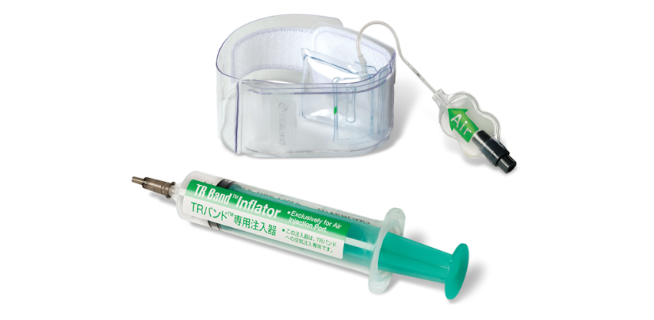

* QuikClot
  + QuikClot is a kaolin-based dressing used in combat situations to control external bleeding.
  + To release pressure gradually, cut every other elastic band on both sides over 30 minutes.
  + After removal of the band, cover the roll with a transparent dressing. The roll may be left in place up to 24 hours. Follow provider’s order.

[](https://www.google.com/url?sa=i&url=https://www.youtube.com/watch?v%3D3rm36BpgyZU&psig=AOvVaw1DY954Q1_3b8tSFeK4JTQt&ust=1585246734626000&source=images&cd=vfe&ved=0CAIQjRxqFwoTCKDwm72etugCFQAAAAAdAAAAABAD)

Cover Roll with Transparent Dressing

**Oxygen Modalities**

Respirator will manage settings. See below to increase O2 as you are calling respiratory.

**Optiflow–**

If the patient desaturates, turn up o2 % on the air oxygen blender, not flow rate, while you wait for respiratory assistance.

**Bipap-**

Bipap can be initiated on step-down, but the provider must do a face to face assessment every 4 hours.

Do not allow patient to eat on bipap unless they can tolerate bipap off for 30 minutes before and after feeding.

To increase f1o2 select button on lower left side and increase up to 100%, while waiting on respiratory assistance.

Patients should be physically capable of removing their mask, if not they must have a 1:1 sitter.

**Trilogy–**

Documented as a mechanical vent, be sure to note liter flow & fio2. Call RT for assistance.

Optiflow

BiPap

Trilogy

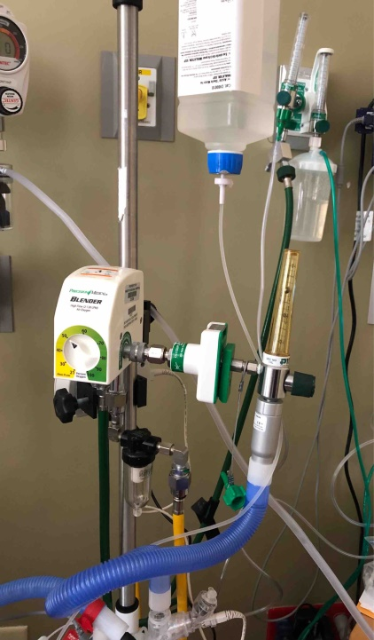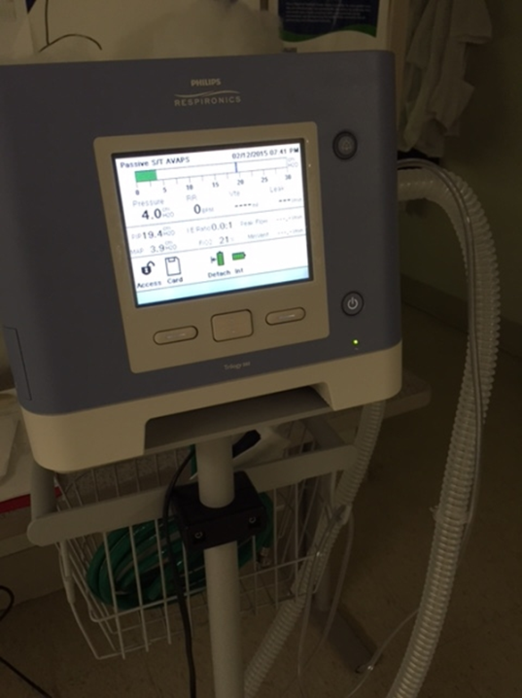

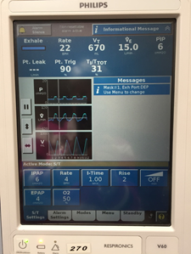

**Chest Tubes**

See Policy State: Chest Tube Insertion and Care for further instruction

Keep sterile gauze and tape at bedside in case of disconnection or accidental removal of tube.

**Care of Chest Tube**

1. Assess and document the amount and character of chest tube drainage every 8 hours or more frequently if output is significant.
2. **Suction may be briefly disconnected if patient to be transferred to another unit**. Confirm with physician if patient can be on gravity for transport or ambulation.
3. Do not clamp chest tube while attached to collection device.
4. In case of accidental disconnection clamp tube with slide clamp.
5. In case of accidental removal of tube: Dress the site with sterile gauze, tape on three sides, leave one side untaped to allow air to escape and prevent tension pneumothorax. Contact physician, assess respiratory status and vital signs. If patient becomes in Respiratory Distress call RRT.

[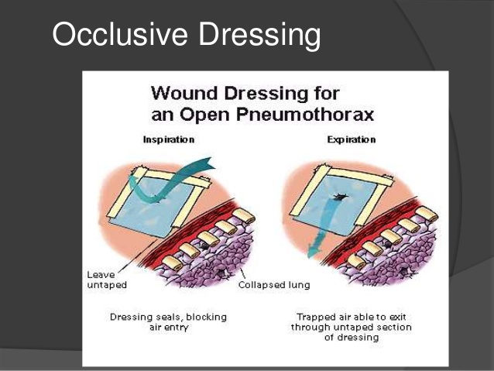](https://www.google.com/url?sa=i&url=https://www.slideshare.net/jameswheeler001/chest-trauma-73197229&psig=AOvVaw0h5ymOHaPCHkR-1jw1iUdM&ust=1585243897037000&source=images&cd=vfe&ved=0CAIQjRxqFwoTCMDAl_aTtugCFQAAAAAdAAAAABAD)**Drips - non-titrated**

**Standards of Care-**

For further information, refer to Micromedex, Up-to-date, or Pharmacy

 1. Continuous cardiac telemetry monitoring is required.

2. Vital signs must be obtained every 4 hours or more frequently if patient condition warrants.

3. A bolus of a drug which will be followed by a non-titrated continuous drip may be given on the Cardiology or Step-down unit and will require more frequent vital signs following the bolus.

4. **Rates/dosage of non-titrated drips may be increased or decreased ONLY per MD order and will require more frequent vital signs following rate/dose change.**

5. Antiarrhythmic, Vasoactive and Vasopressor frequent vital signs at initiation and/or when increased/decreased:

* 15 minutes x2 then,
* 30 minutes x1 then,
* 1 hour x1 then,
* Q 4 hours unless clinically indicated more frequently

|  |  |  |  |
| --- | --- | --- | --- |
| **Antiarrhythmic Drugs** | | | |
| **Drug** | **Action** | **Dosage** | **Interventions** |
| Amiodarone– Cordarone | used to convert Afib to NSR | Must have provider’s order to increase and decrease dose. Typically given at a dose of 1mg/kg for 6 hours and then 0.5mg/kg for 18 hours, then discontinued | * Monitor v/s more frequently. * Notify provider if patient rhythm converts to NSR. * Filter required |
| Cardizem -Diltiazem | Used for atrial arrhythmias, hypertension, chronic stable angina. | Dose range: 5-15 mg/hr  Hard Max: 15 mg/hr | If patient converts to NSR or exhibits low blood pressure or bradyarrythmias, call MD for further clarification on continuing drip or changing dosage. |
| Primicor– Milrinone | Used as short term treatment of heart Failure | Starting rate: 0.1-0.5 mcg/kg/min Maximum rate: 0.75 mcg/kg/min Do not change rate without MD order. Renal adjustment needed. | Monitor BP & HR, follow fluid & electrolyte balance closely |

|  |  |  |  |
| --- | --- | --- | --- |
| **Vasoactive Drugs** | | | |
| **Drug** | **Action** | **Dosage** | **Interventions** |
| Dopamine | used to treat shock, and correct hemodynamic imbalances; to improve perfusion to vital organs; to increase cardiac output, to correct hypotension | Dose range: 2.5-20 mcg/kg/min  Hard Max: 40 mcg/kg/min | Frequently monitor ECG, BP & UOP. Look for signs of adequate CO (Good Bowel Sounds, Cap refill etc) |
| Natrecor- nesiritide | used for Acutely decompensated heart failure patients with dyspnea at rest or minimal activity | Dose range: 0.005-0.03 mcg/kg/min  Hard Max: 0.03 mcg/kg/min | Monitor BP closely; contraindicated in pts with systolic bp <100 |
| Dobutrex– Dobutamine | Uses Increased cardiac output in short term treatment of cardiac decompensation caused by depressed contractility, such as in heart failure | Dose range: 2.5-20 mcg/kg/min  Hard Max: 40 mcg/kg/min |  |

|  |  |  |  |
| --- | --- | --- | --- |
| **Vasopressor** | | | |
| **Drug** | **Action** | **Dosage** | **Interventions** |
| Nitroglycerin | Used for Hypertension, Chest pain, MI | Dose range: 5-400 mcg/min  Hard Max: 400 mcg/min | Monitor BP closely |

|  |  |  |  |
| --- | --- | --- | --- |
| **Other** | | | |
| **Drug** | **Action** | **Dosage** | **Interventions** |
| Lasix-Diuril | Used for Diuresis in Heart Failure patients | Dose range: 10-160 mg/hour  Hard Max: 160 mg/hr | * Monitor BP & Strict I&O * KVO to equal 10ml/hr (another primary) |

|  |  |  |  |
| --- | --- | --- | --- |
| **Anticoagulants** | | | |
| **Drug** | **Action** | **Dosage** | **Interventions** |
| Argatroban | Used Post MI | Soft Min: 0.01 mcg/kg/min  Hard Max: 10 mcg/kg/min | Monitor for S/sx of bleeding |
| Aggrastat-Tirobiban | used in acute coronary syndromes with heparin or aspirin | **Based on CrCl**  Maximum rate (CrCl>60 ml/min): 1350 mcg/hr Maximum rate (CrCl</=60 ml/min): 675 mcg/hr | * Monitor for s/sx of bleeding * Verify order upon arrival from Cath Lab * Be cautious of stop times (place piece of tape on pump stating STOP time) |
| Heparin | Used for therapy for DVT, MI, or PE | Adult- 20,000-40,000 units/day dosed by pharmacy according to ptt. | * Monitor for s/sx of bleeding * Requires two RN witnesses |
| Bivalirudin (Angiomax) | Used on post cath patients | Maximum rate: 2.5 mg/kg/hr  Do not change rate without MD order | Monitor for s/sx of bleeding |