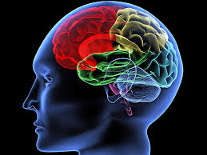
NEUROSURGICAL PROCEDURES

Craniotomy:
- Phenytoin (Dilantin) to manage potential seizures
- Dexamethasone (Decadron)
- Call for any neurological changes and/or other concerns

Pituitary Tumor Resection:
- Hydrocortisone
- Foley with strict UOP q30 mins.
- Urine Specific Gravity and Serum Osmolality for a UOP > 200 cc/hr X 2 (UOP> 300 cc in any hour
- Call for neurological changes and any concerns
NeuroSurgical Patient Complications:
- Seizures Precautions:
BASIC PRECAUTIONS: a potential for seizures is present for all neurosurgical cases
  - Oral airway available on the unit
  - Side rails up and bed in low position
HIGH RISK PRECAUTIONS: ADDITIONAL care for the patient with active seizures
  - Suction equipment readily available
  - Oxygen equipment readily available
- Speech deficits
- Motor strength alteration
- Asymmetrical motor disturbances
- Confusion / memory changes

General Post-Operative Care
- VS and neurologic assessment q15 min. X4, q30 min. X4, qHr X4, then Q4Hr if stable
- Site/dressing
- Pain, nausea
- Pulmonary toiletry
- Bladder/bowel
- Activity: OOB as ordered, may be the evening of surgery

